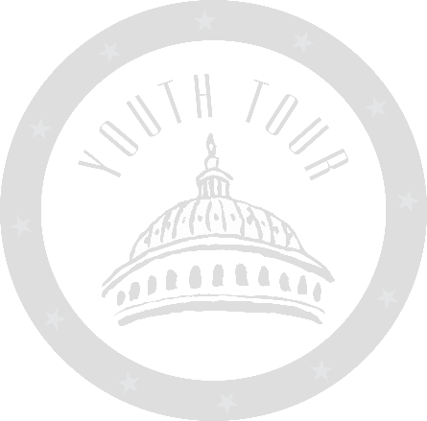

OFFICIAL ENTRY APPLICATION

Enclosed is my application and essay for the “2024 Youth Tour & CYCLE Contest,” sponsored by Tri-County Electric Cooperative

(Student Name)

(Date)

2024 Youth Tour & Cycle Application
Information
Youth Tour: June 14-20, 2024 | CYCLE: July 16-19, 2024

Eligibility:
Any high school student enrolled in the 11th grade (junior) in a high school is eligible for Youth Cycle and Youth Tour as long as they are in the area the cooperative serves. Any high school student enrolled in the 10th grade (sophomore) in a high school is eligible for Youth Cycle as long as they are in the area the cooperative serves. All high school juniors/sophomores students are eligible if:

- They are NOT an immediate family member of a director or an employee of Tri-County Electric Cooperative.
- They mail or fax in the Official Entry Application (enclosed), and one-to-two-page essay by
March 8th, 2024 (Address Below).

Essay Rules:
- Students must submit an essay, the essay topic is "Improving lives through electricity":
  - Meets the one-to-two-page requirement
  - Is Single Spaced or Double Spaced
  - Is 12-point font and Times New Roman

- Essays will be judged based on the following equal components:
  - Originality
  - Composition
  - Neatness
  - Grammar & Syntax
  - Critical Thinking
- All essays received by the March 8, 2024 due date will be judged by an unbiased third party. The judges will then pick two junior students to receive the all-expense-paid trip to Washington, D.C., and two junior students to receive the all-expense-paid trip to CYCLE in Jefferson City. Winners of both Youth Tour and CYCLE will be contacted during the month of April.

Mail to: OR E-Mail to:

Tri-County Electric Cooperative Attn: Youth Tour
P.O. Box 159 Lancaster, MO 63548-0159
smills@tricountyelectric.org

OFFICIAL ENTRY APPLICATION

BIOGRAPHICAL INFORMATION
Name (print): Age:

I Attend High School and am in Grade.
If home schooled state here
My Birthday is:
Month/Day/Year
My Parent(s)/Guardian(s) are:

Our Mailing Address is:

Our Phone Number/s:

My Email Address is:
This can also be your parent(s)/guardian(s) email address
Additional Contact Info (if needed):

PARENT RELEASE FORM

As parent/guardian of , I give my approval for him or her to enter the
Student Name
"Youth Tour & CYCLE Essay Contest,” and if selected to receive either trip, they have my permission to participate on behalf of Tri-County Electric Cooperative.

Signature of Parent/Guardian

Signature of Student
Date

Date

Photo Release Form for Minors (if under 18)
I, am 18 years or older.

I, am the parent/legal guardian of (name, age).

Tri-County Electric Cooperative has my permission to use my child’s photograph publicly to promote the Cooperative during and after Youth Tour/CYCLE. I understand that the images may be used in professional print publications (Rural Missouri), online publications, presentations, websites, and social media.
Please direct any questions to Stephanie Mills at Tri-County Electric Cooperative. Email: smills@tricountyelectric.org 660-457-3733 ext 233.

Parent/Guardian’s Signature: Date .

Phone Number/Email Address: .

OFFICIAL ENTRY APPLICATION
YOUTH TOUR & CYCLE STUDENT PROFILE
- List any extracurricular activities (teams, clubs, organizations, etc.) you participate in:

- In what ways, do you spend your free time?

- What are you education/career plans after high school?

- What is one thing you would do to improve your community?

- Why did you enter this contest?

